Git - Branching
# Source: AI Source: Provided by: [Data Path: Persons Table -> ID Column: 1, Name_En Column: Motasem Essam] -> From: [ChatGPT] on [2/19/2026]
In Git, branch commands are the commands you use to create, view, switch, merge, and delete branches. They let you manage separate lines of development so you can work on features or fixes independently without affecting the main code.

Let's break down each Git branch command with syntax, description, and an example so it’s crystal clear:

1️⃣ Create a New Branch
# Source: AI Source: Provided by: [Data Path: Persons Table -> ID Column: 1, Name_En Column: Motasem Essam] -> From: [ChatGPT] on [2/19/2026]
- Syntax:
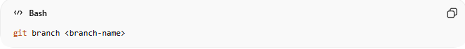
git branch <branch-name>
- Description: Creates a new branch with the given name. You stay on the current branch; it does not switch you automatically.
- Example:
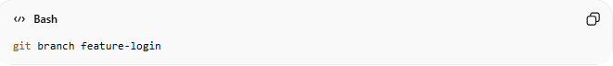
git branch feature-login
Creates a branch called feature-login but you remain on main.

2️⃣ Switch to a Branch

Method 1: Using git checkout
# Source: AI Source: Provided by: [Data Path: Persons Table -> ID Column: 1, Name_En Column: Motasem Essam] -> From: [ChatGPT] on [2/19/2026]
- Syntax:
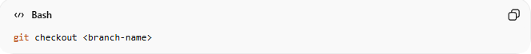
git checkout <branch-name>
- Description:
Switches your working directory to the specified branch so you can start working there.
- Example:
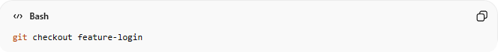
git checkout feature-login
Moves you from main to feature-login.

Method 2: Using git switch (recommended newer command)
# Source: AI Source: Provided by: [Data Path: Persons Table -> ID Column: 1, Name_En Column: Motasem Essam] -> From: [ChatGPT] on [2/19/2026]
- Syntax:
git switch <branch-name>
- Description:
A more modern and intuitive command to switch branches. Works the same as git checkout for switching branches, but avoids confusion with other uses of checkout.
- Example:
git switch feature-login
Moves you from main to feature-login.

3️⃣ Create and Switch at the Same Time
# Source: AI Source: Provided by: [Data Path: Persons Table -> ID Column: 1, Name_En Column: Motasem Essam] -> From: [ChatGPT] on [2/19/2026]

Method 1: Using git checkout -b
# Source: AI Source: Provided by: [Data Path: Persons Table -> ID Column: 1, Name_En Column: Motasem Essam] -> From: [ChatGPT] on [2/19/2026]
- Syntax:
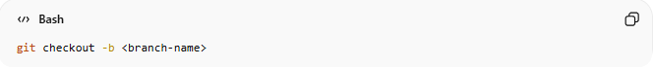
git checkout -b <branch-name>
- Description:
Creates a new branch and immediately switches to it in one step.
- Example:
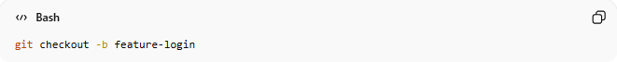
git checkout -b feature-login
Creates feature-login and switches you to that branch, ready to work.

Method 2: Using git switch -c (newer command)
# Source: AI Source: Provided by: [Data Path: Persons Table -> ID Column: 1, Name_En Column: Motasem Essam] -> From: [ChatGPT] on [2/19/2026]
- Syntax:
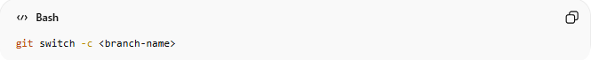
git switch -c <branch-name>
- Description:
A modern alternative to git checkout -b. Creates a new branch and switches to it immediately.
- Example:
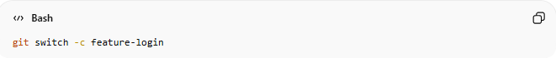
git switch -c feature-login
Creates feature-login and moves you onto it, ready to start working.

4️⃣ List Branches
# Source: AI Source: Provided by: [Data Path: Persons Table -> ID Column: 1, Name_En Column: Motasem Essam] -> From: [ChatGPT] on [2/19/2026]
- Syntax:
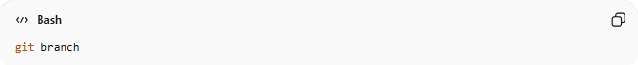
git branch
- Description: Lists all branches in your repository. The current branch is marked with *.
- Example:
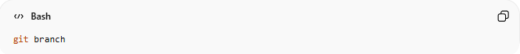
git branch
Output:
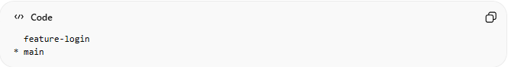
feature-login
* main
Shows two branches; you are currently on main.

5️⃣ Compare Branches

Method 1: Single-space diff (less common / includes working tree)
# Source: AI Source: Provided by: [Data Path: Persons Table -> ID Column: 1, Name_En Column: Motasem Essam] -> From: [ChatGPT] on [2/19/2026]
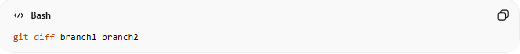
git diff branch1 branch2
Example:
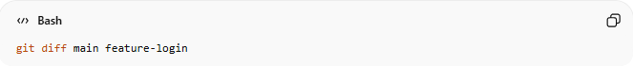
git diff main feature-login
- Compares the contents of the branches along with any unstaged changes in your working directory.
- Can appear empty if there are no differences in the working tree.

Method 2: Double-dot diff (recommended)
# Source: AI Source: Provided by: [Data Path: Persons Table -> ID Column: 1, Name_En Column: Motasem Essam] -> From: [ChatGPT] on [2/19/2026]
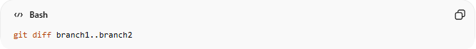
git diff branch1..branch2
Example:
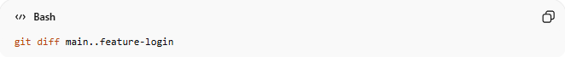
git diff main..feature-login
- Shows only the changes/commits that exist in feature-login but not in main.
- Cleaner and easier to understand when branches diverge.

Method 3: Show only file names that changed
# Source: AI Source: Provided by: [Data Path: Persons Table -> ID Column: 1, Name_En Column: Motasem Essam] -> From: [ChatGPT] on [2/19/2026]
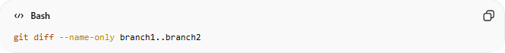
git diff --name-only branch1..branch2
Example:
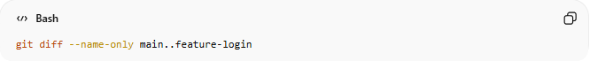
git diff --name-only main..feature-login
- Lists only the files that differ between the branches.
- Useful when you want a quick overview of affected files.

Method 4: Show summary of changes (insertions/deletions)
# Source: AI Source: Provided by: [Data Path: Persons Table -> ID Column: 1, Name_En Column: Motasem Essam] -> From: [ChatGPT] on [2/19/2026]
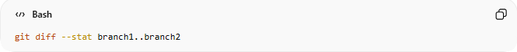
git diff --stat branch1..branch2
Example:
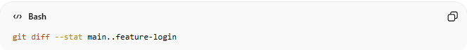
git diff --stat main..feature-login
- Shows a summary of changes including number of insertions, deletions, and files changed.
- Great for a quick sense of branch differences without seeing full content.

✅ Tip: For a full visual overview, you can also use GUI tools like VS Code, GitKraken, or GitHub’s branch compare.

6️⃣ Merge a Branch
# Source: AI Source: Provided by: [Data Path: Persons Table -> ID Column: 1, Name_En Column: Motasem Essam] -> From: [ChatGPT] on [2/19/2026]
- Syntax:
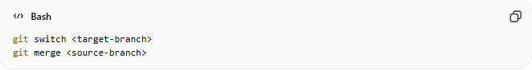
git switch <target-branch>
git merge <source-branch>
- Description: Merges changes from the source-branch into the target-branch. Conflicts may need resolving.
- Example:
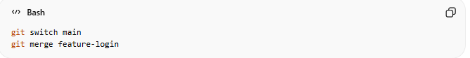
git switch main
git merge feature-login
Combines feature-login changes into main.

7️⃣ Rename branch
# Source: AI Source: Provided by: [Data Path: Persons Table -> ID Column: 1, Name_En Column: Motasem Essam] -> From: [ChatGPT] on [2/19/2026]
Renaming a branch in GitHub can be done both locally (on your machine) and remotely (on GitHub). Here's a clear, step-by-step guide for both.

Method 1: Rename Local Branch (Current Branch)
# Source: AI Source: Provided by: [Data Path: Persons Table -> ID Column: 1, Name_En Column: Motasem Essam] -> From: [ChatGPT] on [2/19/2026]
- Syntax:
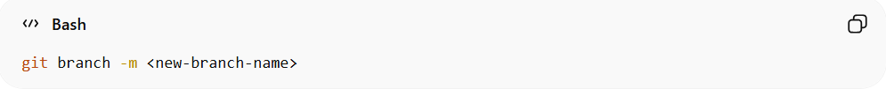
git branch -m <new-branch-name>
- Description:
Renames the branch you are currently on to a new name locally.
- Example:
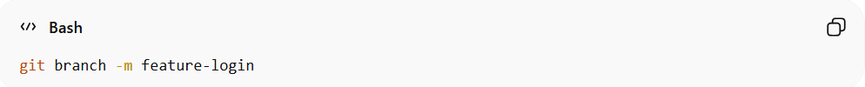
git branch -m feature-login
Renames the current branch to feature-login.

Method 2: Rename Local Branch (Different Branch)
# Source: AI Source: Provided by: [Data Path: Persons Table -> ID Column: 1, Name_En Column: Motasem Essam] -> From: [ChatGPT] on [2/19/2026]
- Syntax:
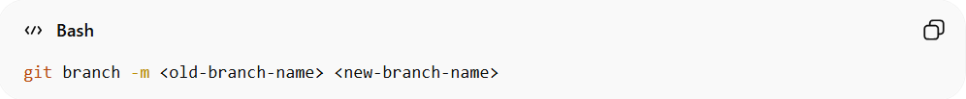
git branch -m <old-branch-name> <new-branch-name>
- Description:
Renames a branch that you are not currently on.
- Example:
git branch -m feature-auth feature-login
Renames branch feature-auth to feature-login locally.

Method 3: Rename the Remote Branch on GitHub

Step 1: Rename the branch locally
# Source: AI Source: Provided by: [Data Path: Persons Table -> ID Column: 1, Name_En Column: Motasem Essam] -> From: [ChatGPT] on [2/19/2026]
Syntax:
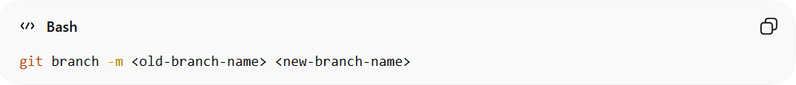
git branch -m <old-branch-name> <new-branch-name>
• Description:
Renames a branch on your local machine. If you are on the branch you want to rename, <old-branch-name> is optional.
• Example:
git branch -m feature-auth feature-login
Renames the local branch feature-auth to feature-login.

Step 2: Delete the old branch on remote
# Source: AI Source: Provided by: [Data Path: Persons Table -> ID Column: 1, Name_En Column: Motasem Essam] -> From: [ChatGPT] on [2/19/2026]
- Syntax:
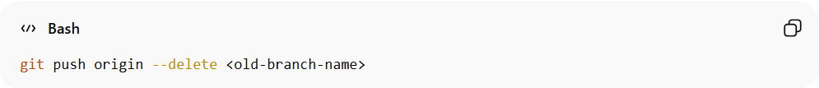
git push origin --delete <old-branch-name>
- Description:
Removes the old branch from the GitHub repository to make way for the renamed branch.
- Example:
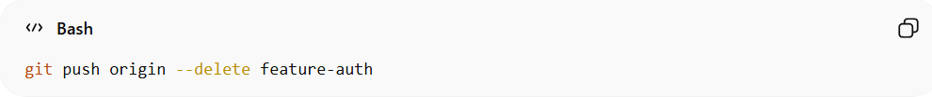
git push origin --delete feature-auth
Deletes the feature-auth branch from GitHub.

Step 3: Push the renamed branch to remote
# Source: AI Source: Provided by: [Data Path: Persons Table -> ID Column: 1, Name_En Column: Motasem Essam] -> From: [ChatGPT] on [2/19/2026]
- Syntax:
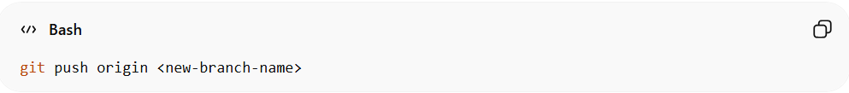
git push origin <new-branch-name>
- Description:
Uploads the locally renamed branch to GitHub.
- Example:
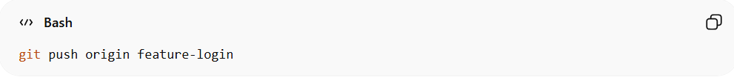
git push origin feature-login
Pushes the local feature-login branch to GitHub.

Step 4: Set upstream for the renamed branch
# Source: AI Source: Provided by: [Data Path: Persons Table -> ID Column: 1, Name_En Column: Motasem Essam] -> From: [ChatGPT] on [2/19/2026]
- Syntax:
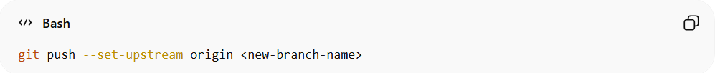
git push --set-upstream origin <new-branch-name>
- Description:
Links your local branch with the remote branch so that future git push and git pull commands track the renamed branch automatically.
- Example:
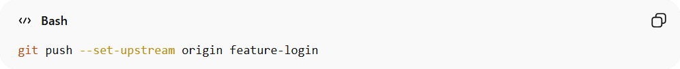
git push --set-upstream origin feature-login
Sets feature-login as the tracked branch on GitHub.

Method 4: Using GitHub Web Interface
# Source: AI Source: Provided by: [Data Path: Persons Table -> ID Column: 1, Name_En Column: Motasem Essam] -> From: [ChatGPT] on [2/19/2026]
GitHub also allows renaming a branch directly in the web interface:
- Go to your repository on GitHub.
- Click on the branches tab.
- Find the branch you want to rename and click the edit (pencil) icon next to it.
- Enter the new branch name and save.
GitHub will automatically update open pull requests to point to the new branch name.

✅ Tip: Always make sure your team knows about the branch rename to avoid confusion with local clones.

8️⃣ Delete a Branch
# Source: AI Source: Provided by: [Data Path: Persons Table -> ID Column: 1, Name_En Column: Motasem Essam] -> From: [ChatGPT] on [2/19/2026]
- Syntax:
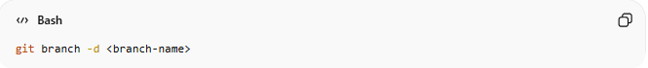
git branch -d <branch-name>
- Description: Deletes a branch that has been merged. Use -D to force delete even if it’s unmerged.
- Example:

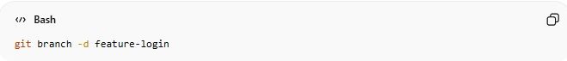
git branch -d feature-login
Removes the feature-login branch from your repository.

--set-upstream (-u)

When you need --set-upstream (-u)
# Source: AI Source: Provided by: [Data Path: Persons Table -> ID Column: 1, Name_En Column: Motasem Essam] -> From: [ChatGPT] on [2/19/2026]
- When you create a brand-new local branch that does not exist on the remote:
  - Example:
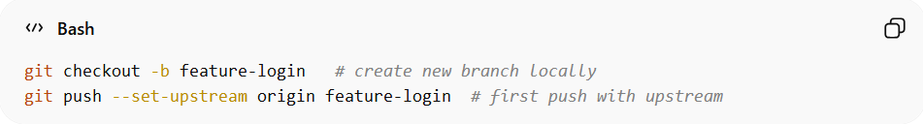
git checkout -b feature-login # create new branch locally
git push --set-upstream origin feature-login # first push with upstream
✅ This sets the branch so future git push and git pull can be done without specifying the branch.
- When you rename a local branch and want the renamed branch to track a remote branch:
  - Example:
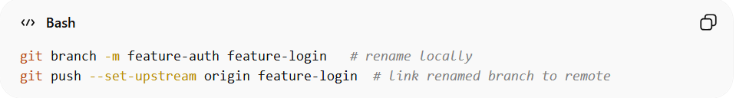
git branch -m feature-auth feature-login # rename locally
git push --set-upstream origin feature-login # link renamed branch to remote
✅ Without this, Git won’t know which remote branch corresponds to your renamed branch.

When you do NOT need --set-upstream
# Source: AI Source: Provided by: [Data Path: Persons Table -> ID Column: 1, Name_En Column: Motasem Essam] -> From: [ChatGPT] on [2/19/2026]
- Branch already exists on remote and you cloned or pulled it:
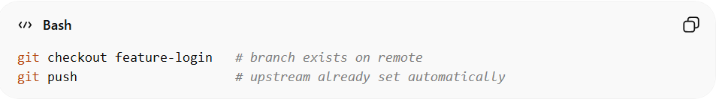
git checkout feature-login # branch exists on remote
git push # upstream already set automatically
- Branch already had upstream set previously.

Why I Must Use --set-upstream (-u)
# Source: AI Source: Provided by: [Data Path: Persons Table -> ID Column: 1, Name_En Column: Motasem Essam] -> From: [ChatGPT] on [2/19/2026]
- Sets the tracking relationship between your local branch and the remote branch.
- Allows you to use simple commands:
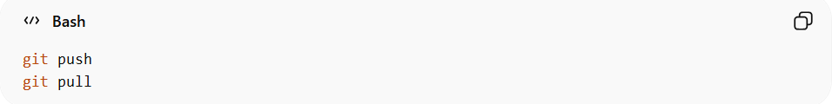
git push
git pull
instead of typing the remote branch name every time.
- Prevents confusion when collaborating with a team because Git knows which remote branch corresponds to your local branch.

What Happens if I Don’t Do This
# Source: AI Source: Provided by: [Data Path: Persons Table -> ID Column: 1, Name_En Column: Motasem Essam] -> From: [ChatGPT] on [2/19/2026]
- Git won’t know which remote branch your local branch should track.
- Every push or pull requires explicit branch specification:
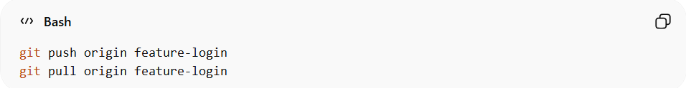
git push origin feature-login
git pull origin feature-login
- Can lead to extra typing, mistakes, or pushing/pulling to the wrong branch.
- After renaming a branch, skipping -u can break automatic pull/push commands for that branch.

Shortcut to remember
# Source: AI Source: Provided by: [Data Path: Persons Table -> ID Column: 1, Name_En Column: Motasem Essam] -> From: [ChatGPT] on [2/19/2026]
- Create a new branch → always push first time with -u.
- Rename a branch locally → push with -u if you want it to track the remote.
- Existing branch with upstream → no -u needed.

So, --set-upstream is needed exactly in these two situations:
- First push of a new branch
- After renaming a branch, to update its tracking on the remote

Example

1️⃣ Create a New Branch
# Source: ScreenShots Source: Provided by: [Persons Table -> ID Column: 1, Name_En Column: Motasem Essam] -> Tool: [Lightshot Program] -> From [Operating System: Windows] on [2/19/2026]
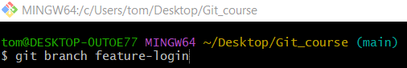
git branch feature-login

2️⃣ Switch to a Branch

Method 1: Using git checkout
# Source: ScreenShots Source: Provided by: [Persons Table -> ID Column: 1, Name_En Column: Motasem Essam] -> Tool: [Lightshot Program] -> From [Operating System: Windows] on [2/19/2026]
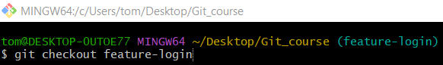
git checkout feature-login

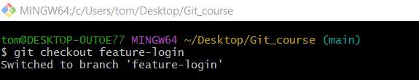

Method 2: Using git switch
# Source: ScreenShots Source: Provided by: [Persons Table -> ID Column: 1, Name_En Column: Motasem Essam] -> Tool: [Lightshot Program] -> From [Operating System: Windows] on [2/19/2026]
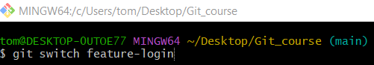
git switch feature-login
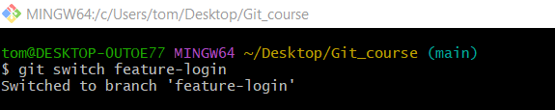

3️⃣ Create and Switch at the Same Time

Method 1: Using git checkout -b
# Source: ScreenShots Source: Provided by: [Persons Table -> ID Column: 1, Name_En Column: Motasem Essam] -> Tool: [Lightshot Program] -> From [Operating System: Windows] on [2/19/2026]
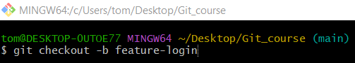
git checkout -b feature-login
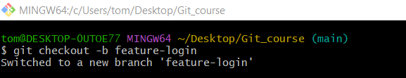

Method 2: Using git switch -c
# Source: ScreenShots Source: Provided by: [Persons Table -> ID Column: 1, Name_En Column: Motasem Essam] -> Tool: [Lightshot Program] -> From [Operating System: Windows] on [2/19/2026]
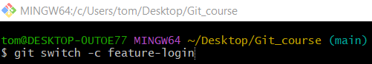
git switch -c feature-login
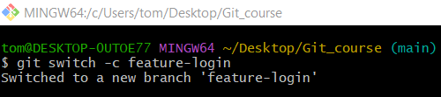

4️⃣ List Branches
# Source: ScreenShots Source: Provided by: [Persons Table -> ID Column: 1, Name_En Column: Motasem Essam] -> Tool: [Lightshot Program] -> From [Operating System: Windows] on [2/19/2026]
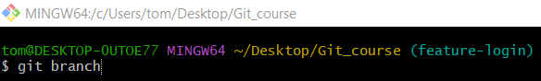
git branch
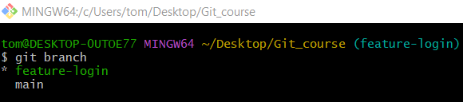

5️⃣ Compare Branches
# Source: ScreenShots Source: Provided by: [Persons Table -> ID Column: 1, Name_En Column: Motasem Essam] -> Tool: [Lightshot Program] -> From [Operating System: Windows] on [2/19/2026]
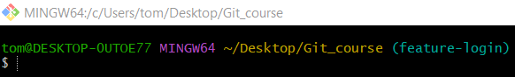
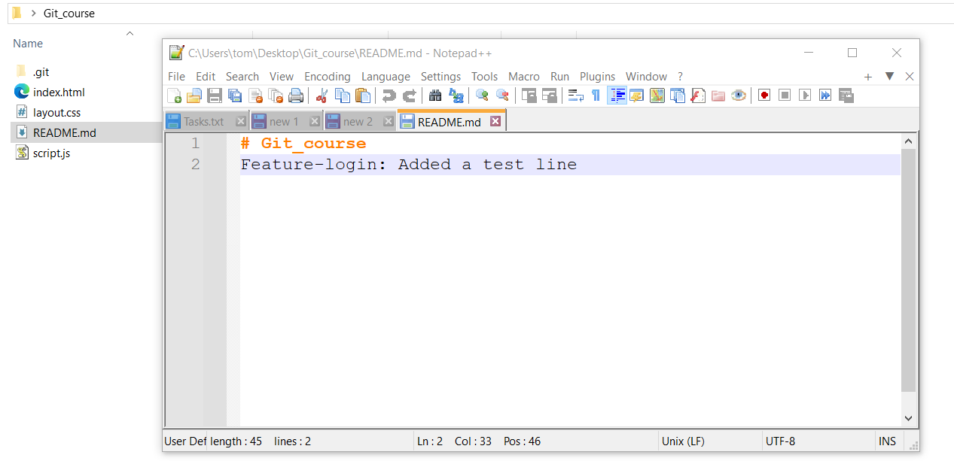
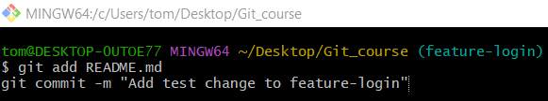
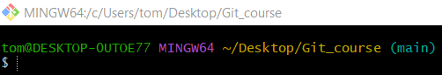
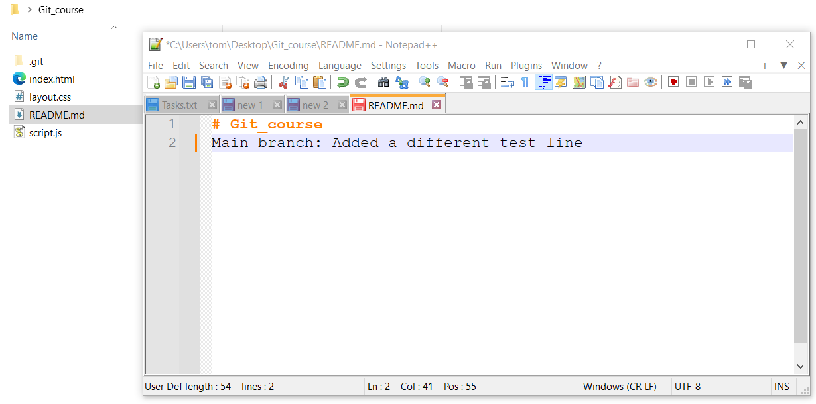
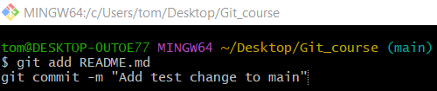

Method 1: Single-space diff
# Source: ScreenShots Source: Provided by: [Persons Table -> ID Column: 1, Name_En Column: Motasem Essam] -> Tool: [Lightshot Program] -> From [Operating System: Windows] on [2/19/2026]
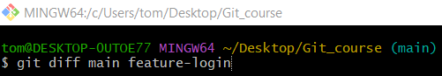
git diff main feature-login
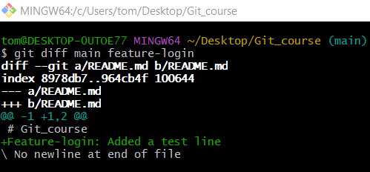

Method 2: Double-dot diff
# Source: ScreenShots Source: Provided by: [Persons Table -> ID Column: 1, Name_En Column: Motasem Essam] -> Tool: [Lightshot Program] -> From [Operating System: Windows] on [2/19/2026]
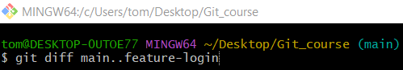
git diff main..feature-login

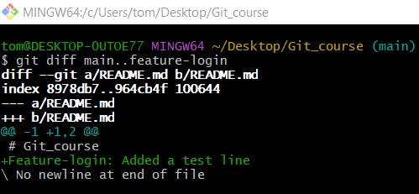

Method 3: Show only file names that changed
# Source: ScreenShots Source: Provided by: [Persons Table -> ID Column: 1, Name_En Column: Motasem Essam] -> Tool: [Lightshot Program] -> From [Operating System: Windows] on [2/19/2026]
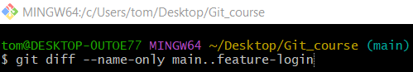
git diff --name-only main..feature-login
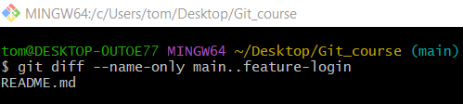

Method 4: Show summary of changes
# Source: ScreenShots Source: Provided by: [Persons Table -> ID Column: 1, Name_En Column: Motasem Essam] -> Tool: [Lightshot Program] -> From [Operating System: Windows] on [2/19/2026]
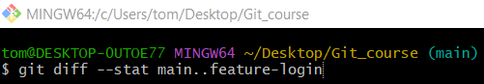
git diff --stat main..feature-login
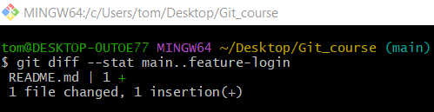

6️⃣ Merge a Branch
# Source: ScreenShots Source: Provided by: [Persons Table -> ID Column: 1, Name_En Column: Motasem Essam] -> Tool: [Lightshot Program] -> From [Operating System: Windows] on [2/19/2026]
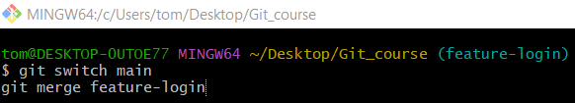
git switch main
git merge feature-login
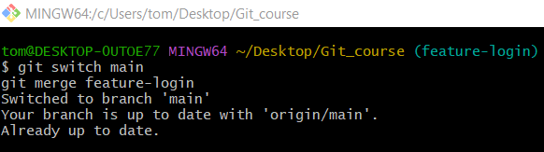

7️⃣ Rename branch

Method 1: Rename Local Branch (Current Branch)
# Source: ScreenShots Source: Provided by: [Persons Table -> ID Column: 1, Name_En Column: Motasem Essam] -> Tool: [Lightshot Program] -> From [Operating System: Windows] on [2/19/2026]
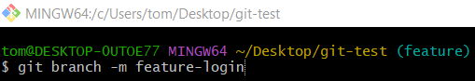
git branch -m feature-login
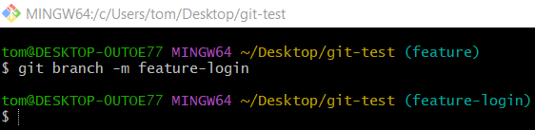

Method 2: Rename Local Branch (Different Branch)
# Source: ScreenShots Source: Provided by: [Persons Table -> ID Column: 1, Name_En Column: Motasem Essam] -> Tool: [Lightshot Program] -> From [Operating System: Windows] on [2/19/2026]
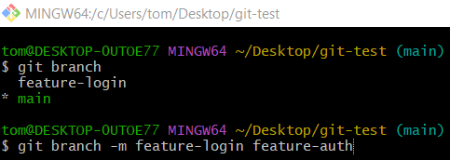
git branch -m feature-login feature-auth
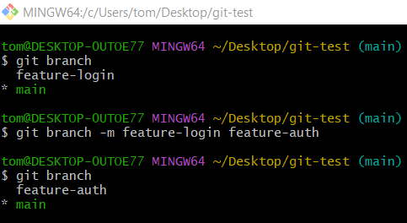

Method 3: Rename the Remote Branch on GitHub

Step 1: Rename the branch locally
# Source: ScreenShots Source: Provided by: [Persons Table -> ID Column: 1, Name_En Column: Motasem Essam] -> Tool: [Lightshot Program] -> From [Operating System: Windows] on [2/19/2026]
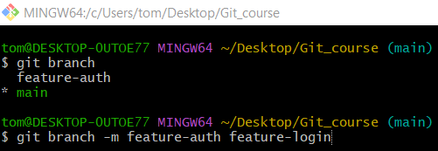
git branch -m feature-auth feature-login
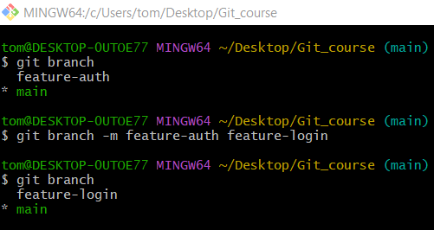

Step 2: Delete the old branch on remote
# Source: ScreenShots Source: Provided by: [Persons Table -> ID Column: 1, Name_En Column: Motasem Essam] -> Tool: [Lightshot Program] -> From [Operating System: Windows] on [2/19/2026]
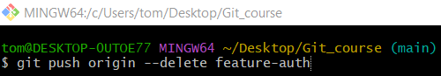
git push origin --delete feature-auth
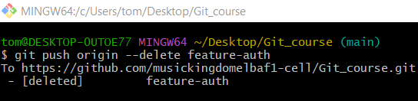

Step 3: Push the renamed branch to remote
# Source: ScreenShots Source: Provided by: [Persons Table -> ID Column: 1, Name_En Column: Motasem Essam] -> Tool: [Lightshot Program] -> From [Operating System: Windows] on [2/19/2026]
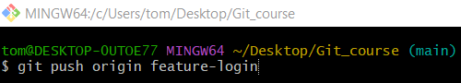
git push origin feature-login
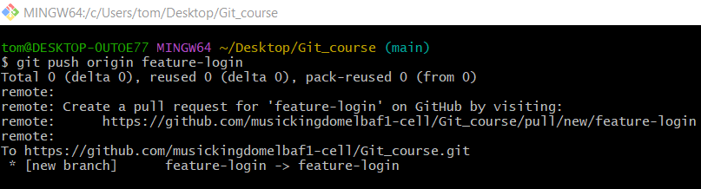

Step 4: Set upstream for the renamed branch
# Source: ScreenShots Source: Provided by: [Persons Table -> ID Column: 1, Name_En Column: Motasem Essam] -> Tool: [Lightshot Program] -> From [Operating System: Windows] on [2/19/2026]
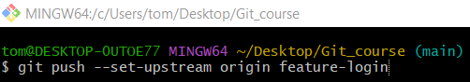
git push --set-upstream origin feature-login
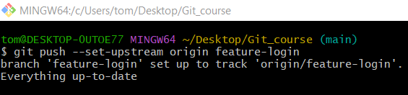

Method 4: Using GitHub Web Interface
# Source: ScreenShots Source: Provided by: [Persons Table -> ID Column: 1, Name_En Column: Motasem Essam] -> Tool: [Lightshot Program] -> From [Site: https://github.com] on [2/19/2026]
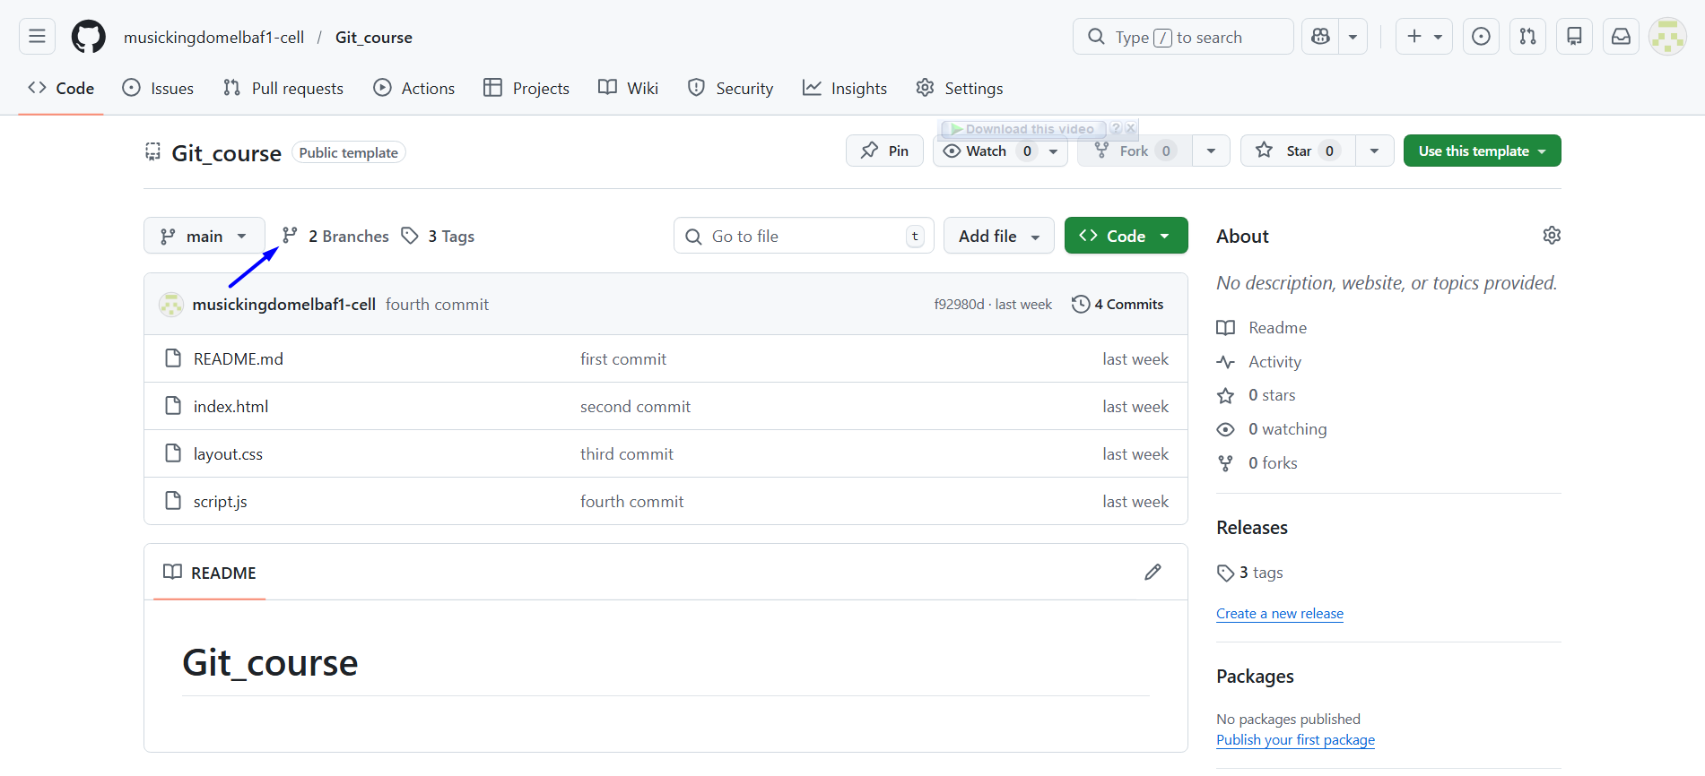
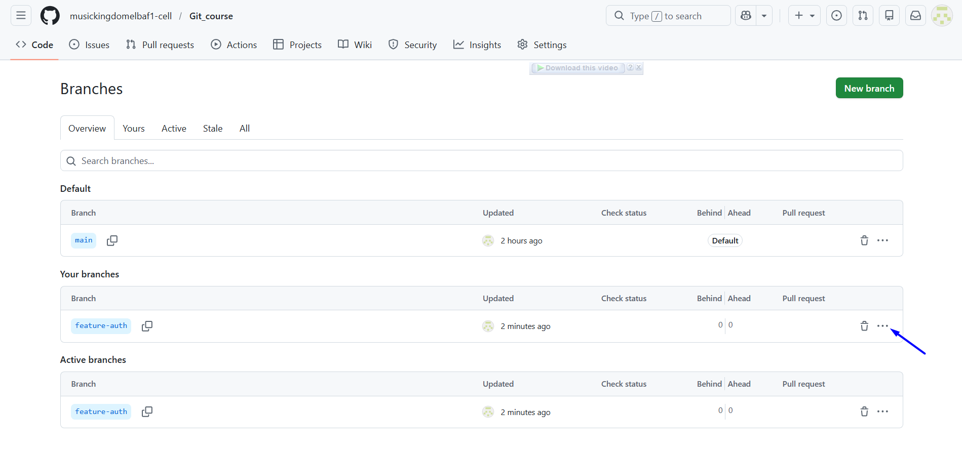
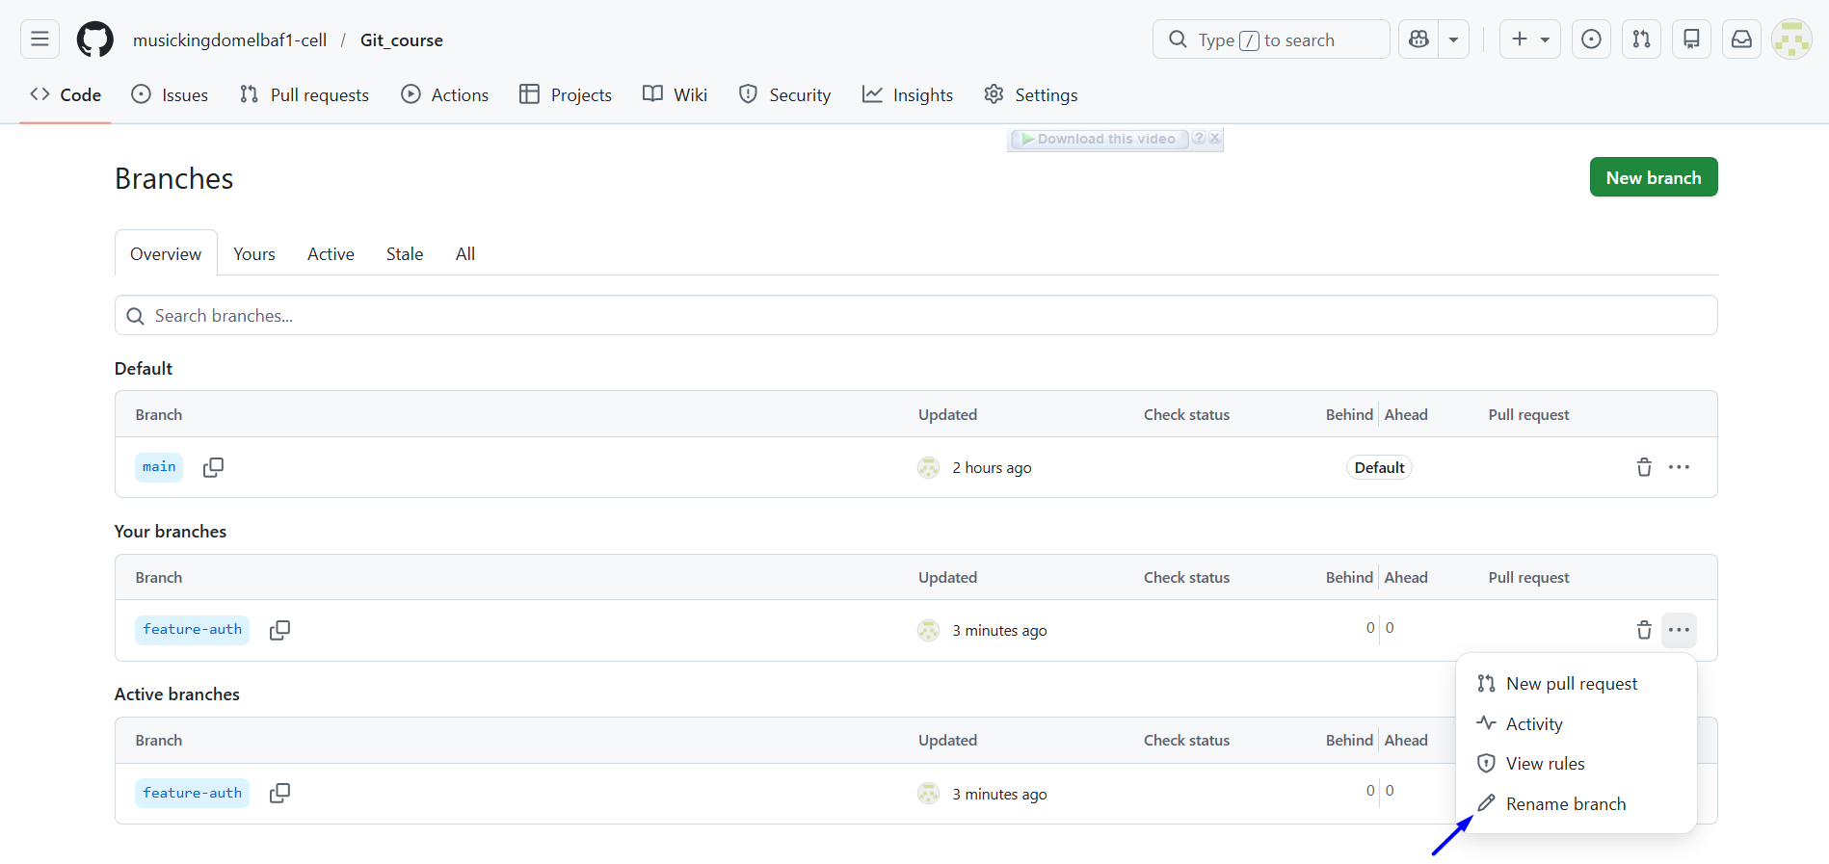
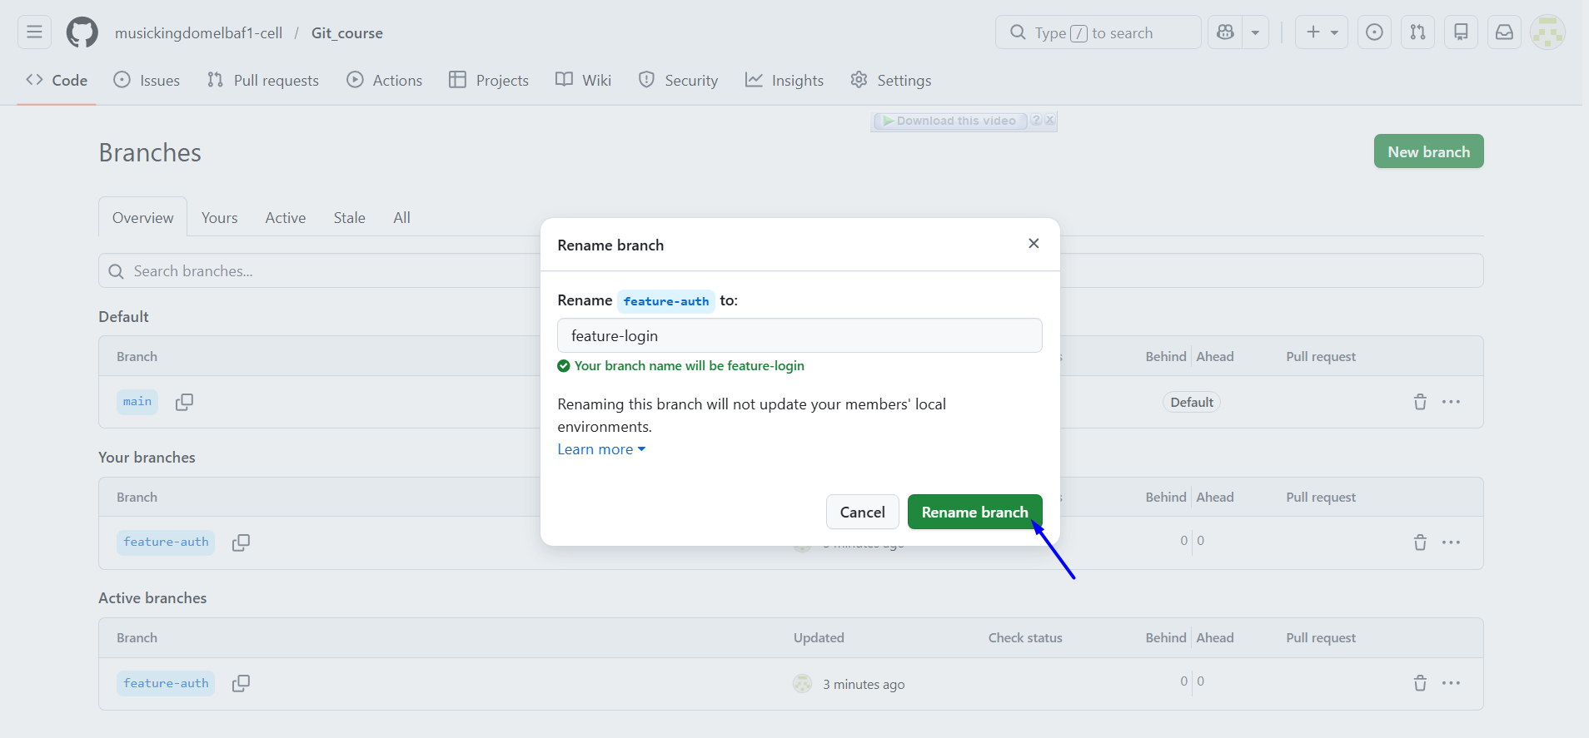
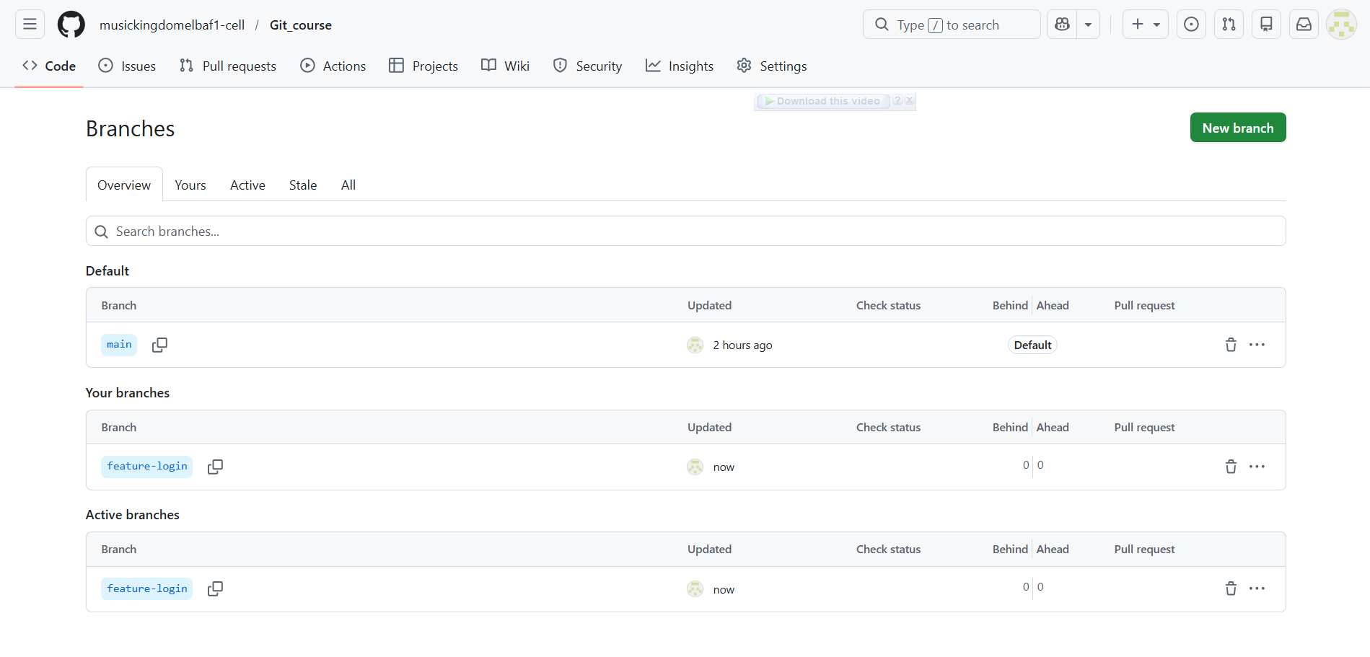

8️⃣ Delete a Branch

Method 1: Delete Local Branch
# Source: ScreenShots Source: Provided by: [Persons Table -> ID Column: 1, Name_En Column: Motasem Essam] -> Tool: [Lightshot Program] -> From [Operating System: Windows] on [2/19/2026]
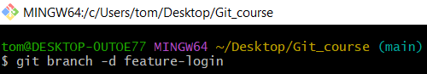
git branch -d feature-login
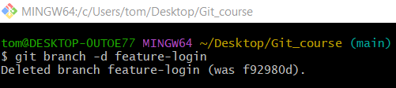
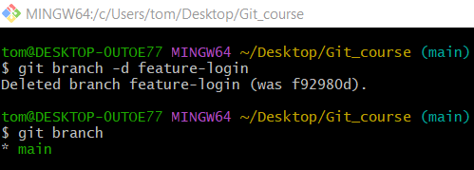

Method 2: Using GitHub Web Interface
# Source: ScreenShots Source: Provided by: [Persons Table -> ID Column: 1, Name_En Column: Motasem Essam] -> Tool: [Lightshot Program] -> From [Site: https://github.com] on [2/19/2026]
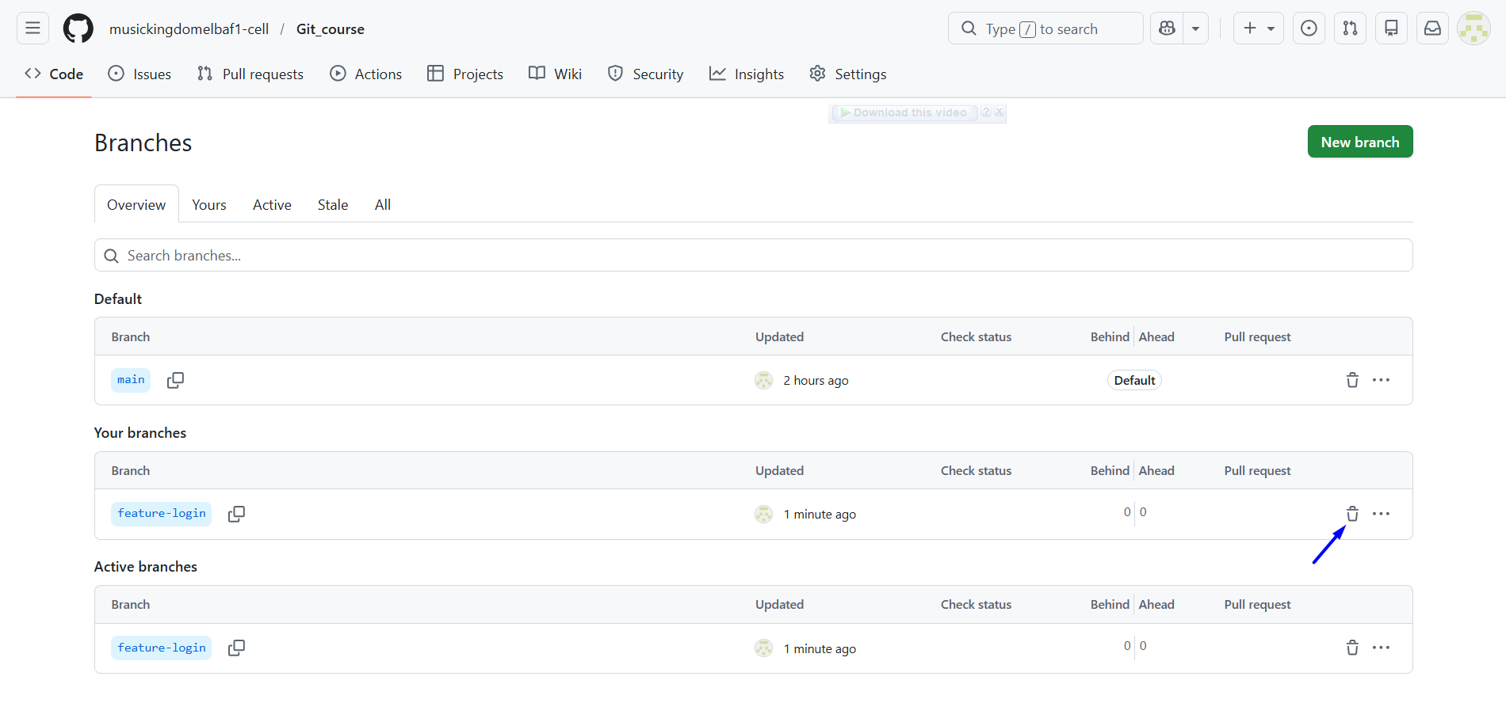
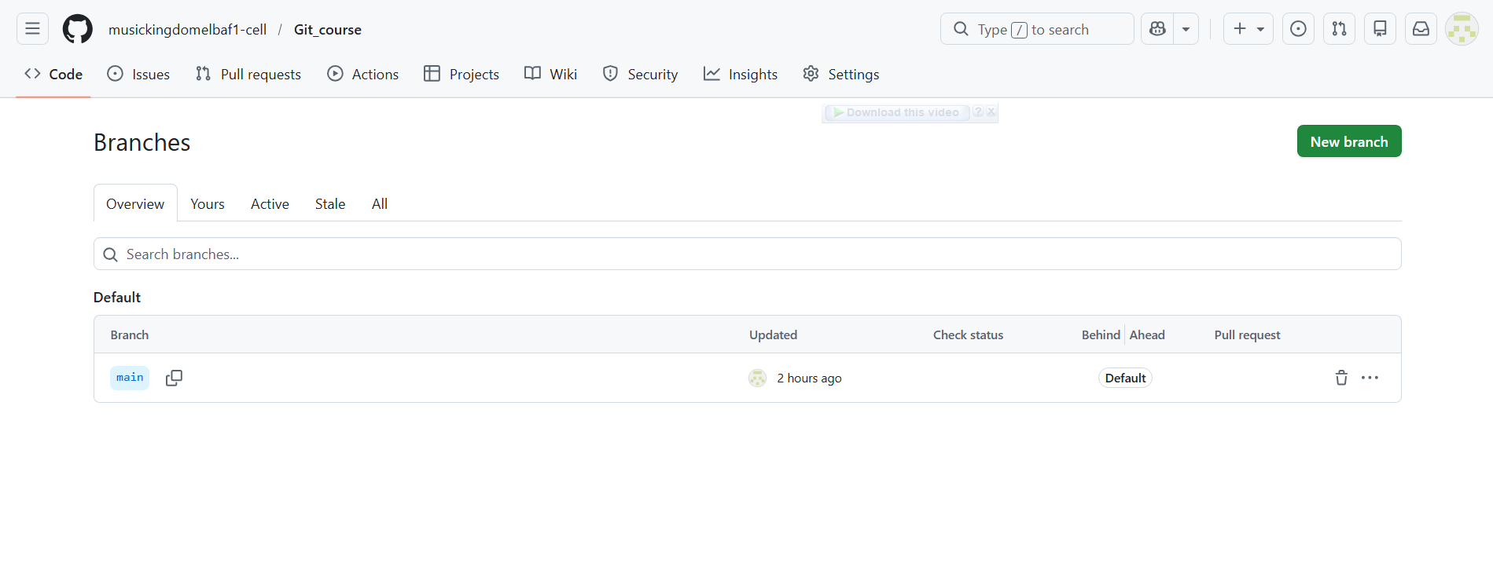

Create branch in Visual Studio Code
# Source: ScreenShots Source: Provided by: [Persons Table -> ID Column: 1, Name_En Column: Motasem Essam] -> Tool: [Lightshot Program] -> From [Operating System: Windows] on [2/19/2026]
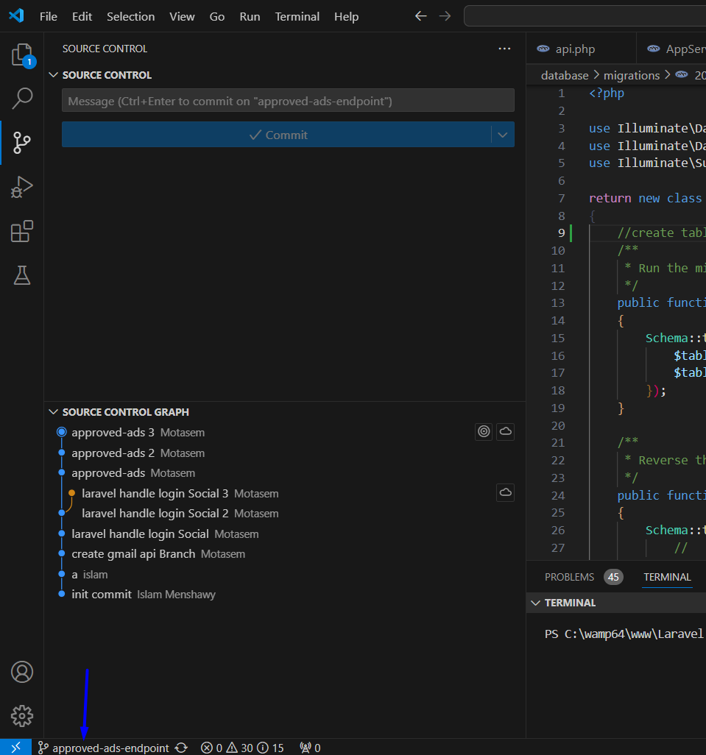
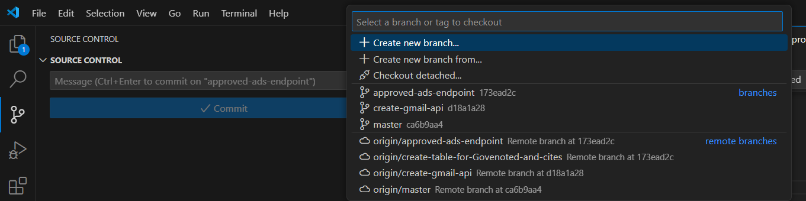
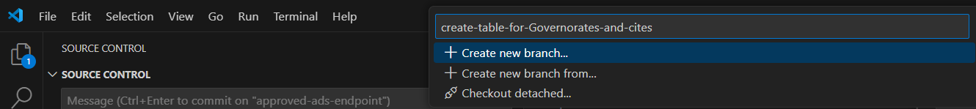
create-table-for-Governorates-and-cites
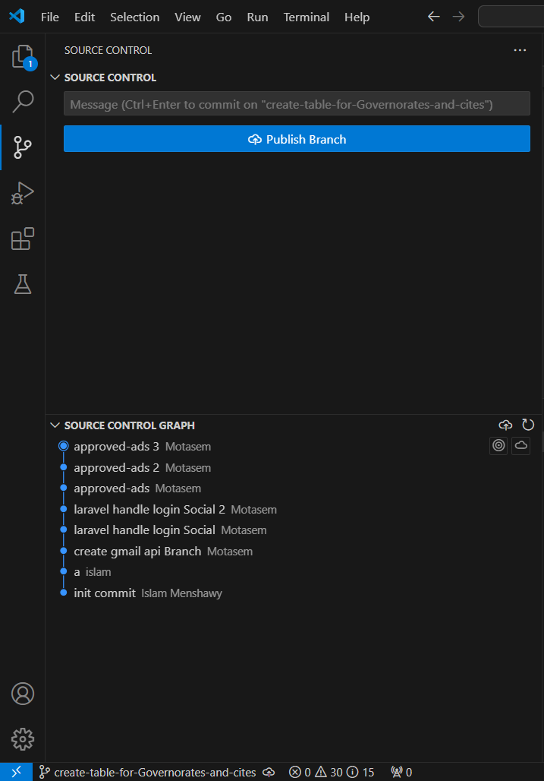

git push --set-upstream origin create-table-for-Governorates-and-cites
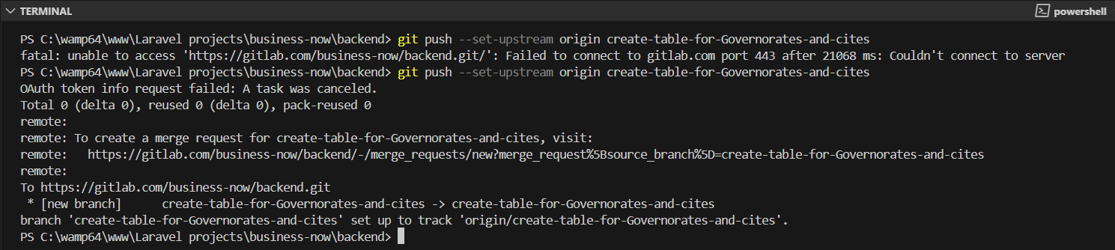
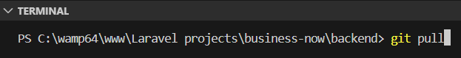
git pull
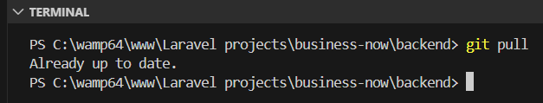

Create branch with jira

Step 1 open jira
# Source: ScreenShots Source: Provided by: [Persons Table -> ID Column: 1, Name_En Column: Motasem Essam] -> Tool: [Lightshot Program] -> From [Site: https://www.atlassian.com] on [2/19/2026]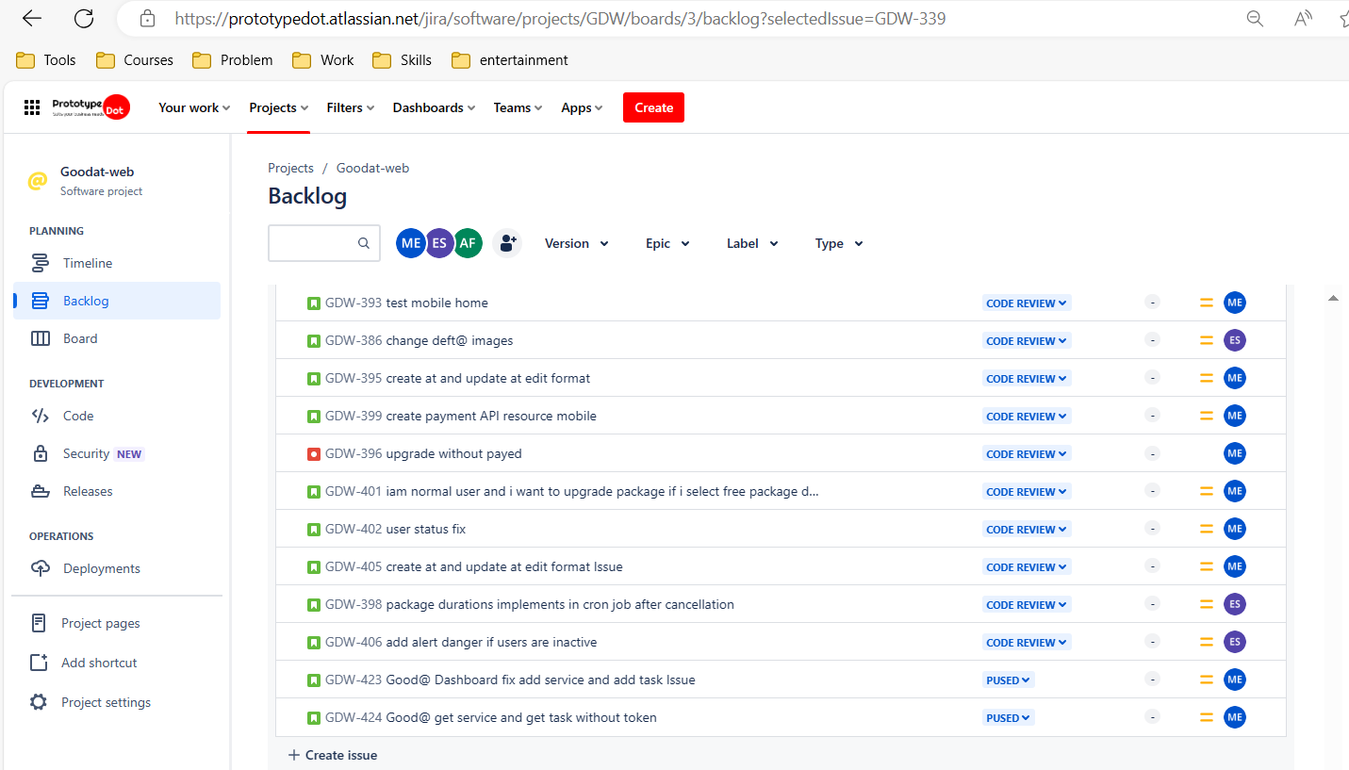

Step 2 create ticket
# Source: ScreenShots Source: Provided by: [Persons Table -> ID Column: 1, Name_En Column: Motasem Essam] -> Tool: [Lightshot Program] -> From [Site: https://www.atlassian.com] on [2/19/2026]
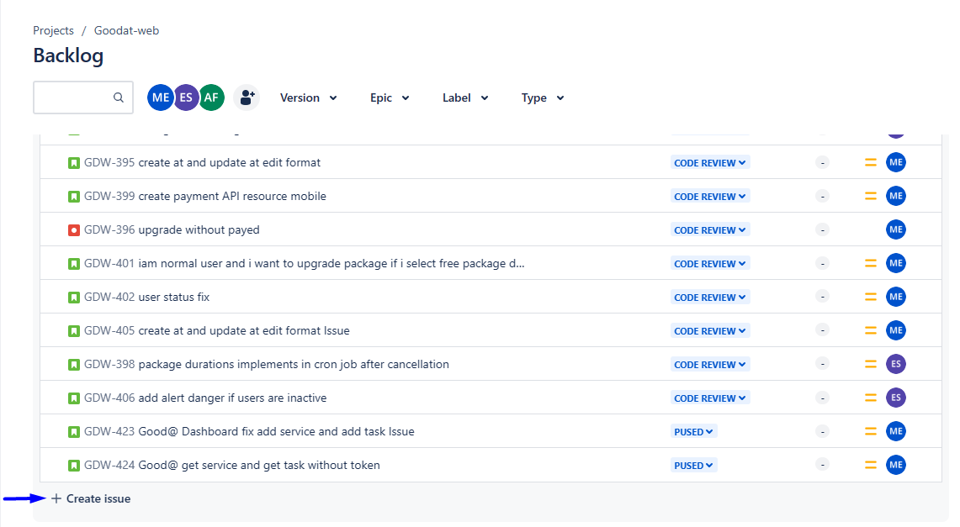


Step 3 create branch
# Source: ScreenShots Source: Provided by: [Persons Table -> ID Column: 1, Name_En Column: Motasem Essam] -> Tool: [Lightshot Program] -> From [Site: https://www.atlassian.com] on [2/19/2026]
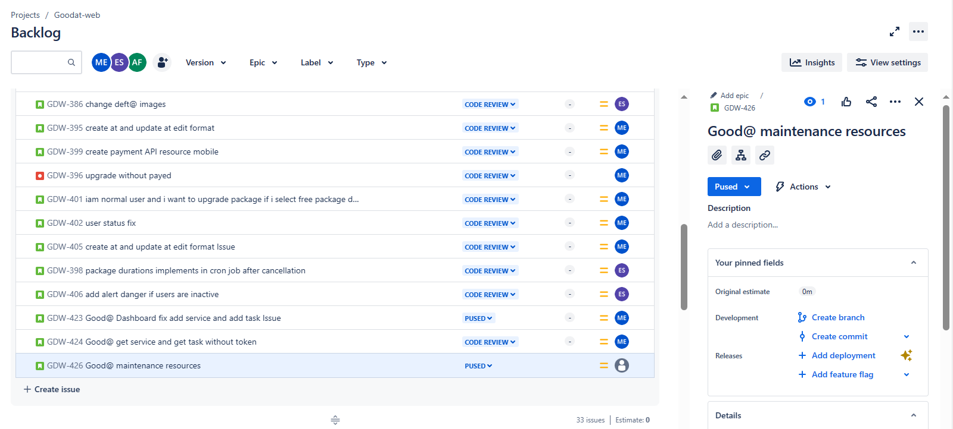
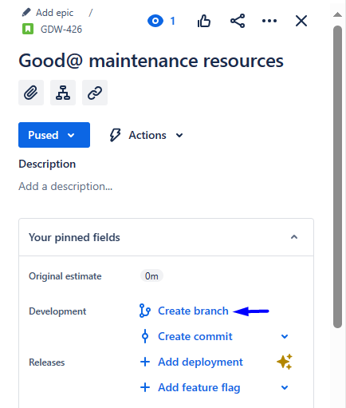
# Source: ScreenShots Source: Provided by: [Persons Table -> ID Column: 1, Name_En Column: Motasem Essam] -> Tool: [Lightshot Program] -> From [Site: https://gitlab.com] on [2/19/2026]
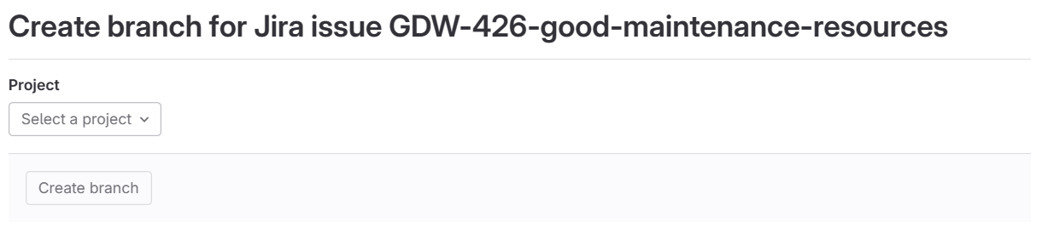
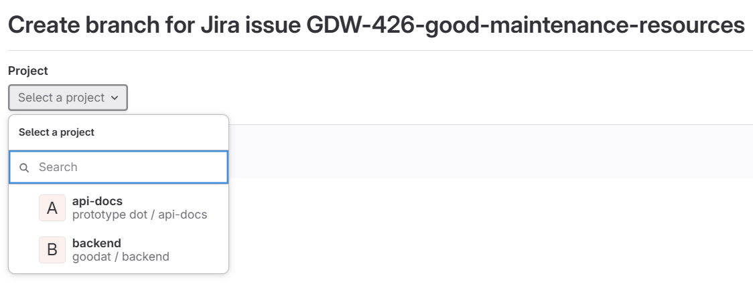
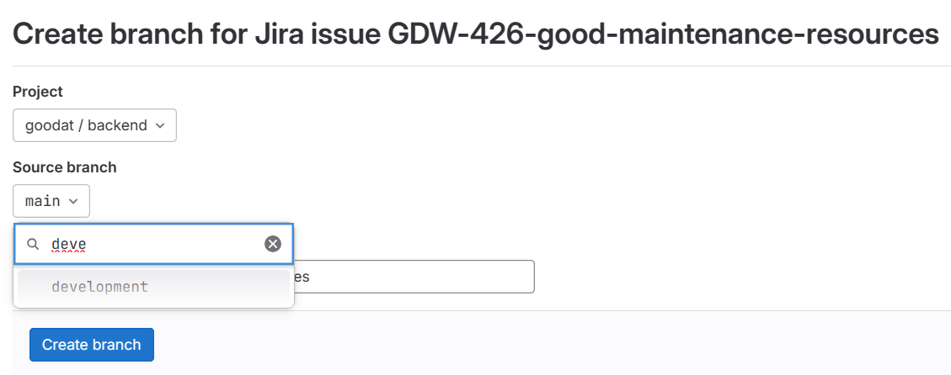
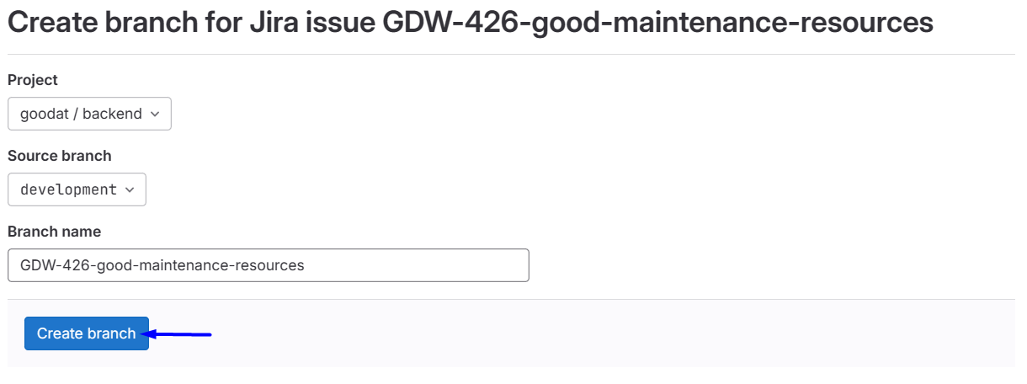
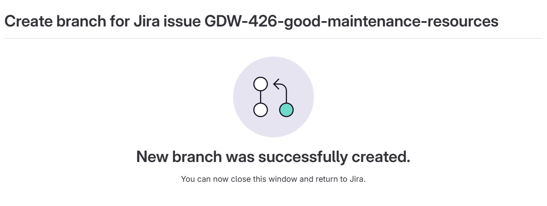
# Source: ScreenShots Source: Provided by: [Persons Table -> ID Column: 1, Name_En Column: Motasem Essam] -> Tool: [Lightshot Program] -> From [Site: https://www.atlassian.com] on [2/19/2026]
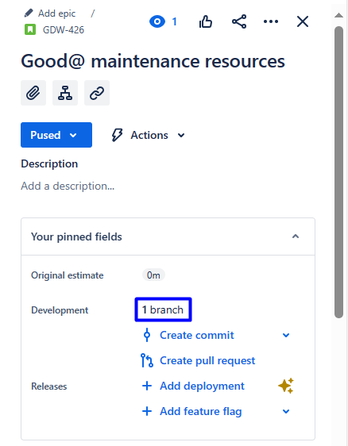

Step 4 open branch
# Source: ScreenShots Source: Provided by: [Persons Table -> ID Column: 1, Name_En Column: Motasem Essam] -> Tool: [Lightshot Program] -> From [Operating System: Windows] on [2/19/2026]
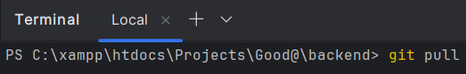
git pull
